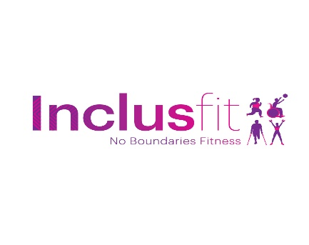Inclusfit Physical Activity Readiness Questionnaire

Name………………………………………………………………………………………………..
DOB ……………………………………………… E-mail ……………………………………………….
Address ……………………………………………………………………………..........................................................................................................................................................................................................................................
Postcode ……………………………….. Tel ………………………………………..
ICE # ………………………………………………………..(in case of emergency)

Please tick if you have been diagnosed with any of the following:
Heart Condition □ Diabetes □ Asthma □
High Blood Pressure □ Epilepsy □

Please tick if you have experienced any of the following:

Fainting/Dizziness □ Joint Injury □ Stroke □
Pains in the chest □ Back Injury □ Arthritis □
Illness/Operation □ Are you pregnant or 6 weeks post natal □
Migraines / Headaches □ Are you a smoker? Yes / No
If you have any other conditions / Disability not yet mentioned that may affect the exercise that you can do, please specify ………………………………………………………………………………………… ………………………………………………………………………………………… …………………………………………………………………………………………
If you have ticked any of the above, please give details of conditions, medications and approximate date cleared …………………………………………………………………………………………………………………………………………………………………………………… …………………………………………………………………………………………
…………………………………………………………………………………………

All the information on this form is true to the best of my knowledge and I have sought and followed any necessary medical advice. I understand that my instructor, Sam James, will not be held responsible for any accident or injury sustained unless due to negligence.

Client Sign & Date …………………………………………………………………

Instructor Sign & Date ……………………………………………………………

Please note Photographs / filming may take place during class, are you happy for you to appear in these? Yes or No (please circle)
I do not want to be added to the Inclusfit newsletter □
If you have ticked any of the boxes overleaf and have not provided a note from your doctor please sign and complete the following prior to undertaking any training with me
My doctor has cleared / advised me to exercise
Client signature …………………………………………………………………….

Specific advice given by doctor …………………………………………..............………………………………………………………………………………………… …………………………………………………………………………………………………………………………………………………………………………………… …………………………………………………………………………………………
Doctor’s name and surgery ………………………………………………………..………………………………………………………………………………………… …………………………………………………………………………………………

Data Protection-This information will be stored in line with the General Data Protection Regulation (GDPR)and the Privacy Policy of Inclusfit.

